Project Plan
Group E, Year 1 IT, Period 1
Contents
- Team and Project Overview 3
  - Team Members 3
  - Project Description 3
- Introduction to Project Phases 6
  - Phase I – Planning and Preparation 6
  - Phase II – Individual Designs 6
  - Phase III – Web Development and Additional Features 8
  - Phase IV – Final Presentation 10
- Charts 10
  - Breakdown of Network Diagram / PERT Chart 11
  - Gantt Chart 12
- Team and Project Overview
  - Team Members
The team consists of six members. Each member is responsible for specific pages, features and functionalities.
- Tamás Olivér Kiss — Team Leader
- Réka Laura Szunyogh-Kocsis — Co-Leader, Minutes Secretary
- Muhammad Umar Kamran
- Oleksii Khomiak
- Ngangfor Sustain Amungwa
- Aynur Tozluyurt
  - Project Description
The Client (Sunny Socks) has requested a website, that not only showcases their products, but also reflects their values.
    - Project Requirements
The Client requested:
- An engaging homepage
- An ‘About us’ page that reflects Sunny Socks’ mission, vision and values
- A product overview that showcases all of Sunny Socks’ products
- A sustainability page that explains the ethical manufacturing of Sunny Socks’ products
- A contact page that provides a form and further company information
- A responsive design, functional for mobile and tablet
- Integration of brand identity, such as colours, typography and illustrations
The Client’s further requests:
- A clear introduction to Sunny Socks’ Pride campaign on the homepage
- A Pride page that explains Sunny Socks’ values and support for the movement
- References from other pages, such as the ‘About us’ page
    - Reflected Values
Sunny Socks is a company that prioritises its values regarding people, sustainability and positivity. Sunny Socks’ values include:
- Sustainability and fairness, respecting the people involved in the manufacturing process and our planet
- Inclusivity, ensuring that all customers feel welcome and represented
- Positivity, looking on the bright side and thinking of every problem as a chance to find a new solution
    - Branding and Sources
The Sunny Socks brand relies on elements to ensure that the brand’s image is cohesive and consistent. The visual sources are the following:
- Typography: The usage of the fonts “Nexa Light” for the body text and “Nexa Bold” for the titles, subtitles and emphasis
- Colours: The usage of the five brand colours — blue (#1e407a), green (#4fb2a2), pink (#e990b9), orange (#f15b39), yellow (#fecd3e)
- Logos: with and without slogan, in all five colours
- Illustrations, packaged sock images
The Sunny Socks brand has a clear mission and vision.
- Mission: To brighten people’s day by providing high quality, ethically produced socks.
- Vision: To produce ethical and sustainable socks that are available for everybody.
To best achieve this, the following steps shall be taken:
- Visual appeal with harmonising colours and well-placed images
- User-friendliness, making sure that the webpage is accessible with its simplistic design, intuitive layout and predictable function
- To convey the brand story, the sources provided by the Client (slogan, colours, typography, etc.) should be used to show the brand’s mission and vision
- Introduction to Project Phases
  - Phase I – Planning and Preparation
    - Code of Conduct
The Code of Conduct aims to provide an outline to groupwork, regulating the manner in which meetings are to be held, the communication between members and it outlines other general rules. The Code of Conduct is to be unanimously accepted and signed by all team members to be considered valid.
    - Project Discussion
Before any work begins, the team discusses the project together. In order to avoid misunderstandings, every team member explains their interpretation of the tasks and if any disagreements arise, the team asks for clarification from the Client.
  - Phase II – Individual Designs
    - Analysis Board
Every team member is to create an analysis board. The board should include general information about the project, sources provided by Sunny Socks, wireframes for each page and inspiration. The analysis board is to be updated if the Client has further requests.
    - Iterations 1, 2 and 3
Each team member is to design a website for Sunny Socks. The website should have most functionalities and should be prototyped in Figma.
Iteration 1 is to be based on the initial information received from the Client.
The second iteration builds on the first iteration, incorporating further requests from the Client.
Iteration 3 should be the final version of the individual design. It relies on feedback received from the usability test regarding the second iteration.
    - Usability Test
Each team member is to create a usability test after finishing the second iteration. The questions aim to find weaknesses within the design and possible points for improvement. The questionnaire is to be created using an online software. Using the feedback received, each individual updates their second iteration, thus creating their third and final design.
    - Advisory Meeting
After every team member has their final design, the Client should be contacted for an advisory meeting. In this meeting, everyone goes through their final design, explaining each decision that was made. The Client takes note of each design and asks questions if needed. Finally, the Client makes a decision, choosing one of the designs to be coded by the team. The team member whose design was chosen helps lead the team, regarding design-related inquiries.
  - Phase III – Web Development and Additional Features
    - Coding Conventions
Before starting the joint groupwork, the team decides the coding conventions that are to be followed, to ensure a consistent coding style.
      - HTML
The usage of dynamic linking is mandatory, to ensure that images, fonts and other sources are loaded correctly.
The proper indentation ensures the readability of each team member’s code. This also applies to CSS files.
Line breaks may only be used when necessary.
Comments should be used only when the code may be confusing to other developers.
The characters and letters used in coding must be ASCII compliant and further symbols may be included using their proper HTML entity tags.
      - CSS
The CSS files should all start with the addition of the font families “Nexa Light” and “Nexa Bold”.
Class and ID names should be clear and representative of the functions they display. Classes should only be specified if they apply to multiple elements, otherwise IDs are to be used.
Each curly bracket (“{“, “}”) should occupy one line alone, with the opening bracket to start one line after the class/ID/function name.
Before and after every function, an empty line is to be used, for clear readability.
    - Division of Work
The team discusses who will take on which parts of the project. This includes all designs or work outside of the website’s design.
      - Tamás Kiss — Header and footer design, homepage design, design of further templates (striped and classic socks pages), media checks
      - Réka Szunyogh-Kocsis — Pride page and 404-page design, creation of background and further images, striped and classic socks pages, taking minutes, creation of charts and project plan
      - Muhammad Umar Kamran — ‘About us’ page design, advanced functions design (chatbot)
      - Oleksii Khomiak — Contact page design, including fully-functional form
      - Aynur Tozluyurt — Sustainability page design and further visual design (fonts, images, visual harmony)
  - Phase IV – Final Presentation
The final presentation is to include a PowerPoint presentation as well as the final version of the website.
    - PowerPoint Presentation
The PowerPoint is to explain key features and functionalities. It aims to introduce the Client to the final product without going into too much detail.
    - Demonstration
Before the presentation, the projector should be tested by a team member, to ensure everything is displayed correctly.
The number of team members presenting is to be decided.
The time allocated to each section of the presentation is to be proportionate to each other. The introduction and closing statements are to be brief and clear, leaving enough time for the demonstration of the website.
The team members’ attire should be smart casual.
- Charts
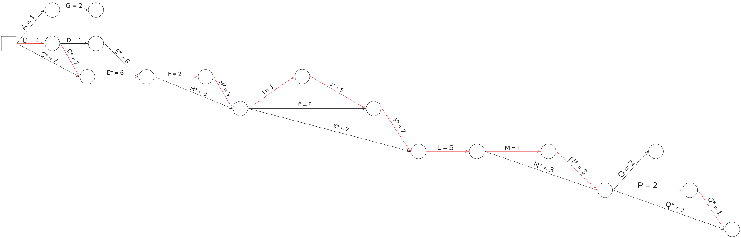
  - Breakdown of Network Diagram / PERT Chart

  - Gantt Chart

